**//Code for the evaluation question**

void setup()

{

pinMode(13, OUTPUT); *//It defines that there is an output device connected*

*at pin number 13 of the arduino board*

pinMode(12,OUTPUT); *//It defines that there is an output device connected*

*at pin number 12 of the arduino board*

pinMode(11,OUTPUT); *//It defines that there is an output device connected*

*at pin number 11 of the arduino board*

pinMode(2,INPUT); *//It defines that there is an input device connected*

*at pin number 2 of the arduino board*

}

void loop()

{ int i;

int keyState = digitalRead(2);

if(keyState = 1)*//if the key state is in high position*

{

for(i=0;i<10;i++)*//it will execute execute our code for 10 times*

{ *//for blinking the LEDs at pin 13 & 12 alternatively for 500 ms*

digitalWrite(13, HIGH);

digitalWrite(12, LOW);

delay(500);

digitalWrite(12,HIGH);

digitalWrite(13,LOW);

delay(100);

*//for buzzing the buzzer at pin 11 for 1000 ms*

digitalWrite(11,HIGH);

delay(1000);

digitalWrite(11,LOW);

delay(1000);

}

}

}

**Circuit diagram:-**

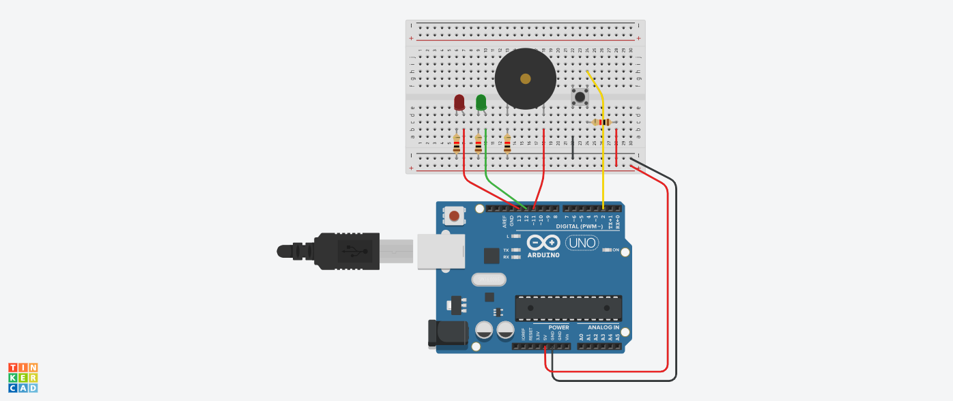

**Theory:-**

The concepts used in this project are:-

* Whenever a box is opened i.e. push button is pushed the two LEDs will glow alternatively and the buzzer will be buzzing sound for 1000 ms as long as the box is opened.
* When the switch button is pushed off all component will stop.

**Learning outcomes:-**

I have learned through this project that how to blink 2 LEDs and a buzzer alternatively.

**Observations:-**

* When we pass electrical signals through our code the program is executed coorectly.
* The 2 LEDs are glowing alternatively and simultaneously the buzzer is buzzing.

**Problems faced:-**

The problems I faced:-

* The circuit was not working because the connections were not proper.
* The LED was in a bad condition.

**Precautions:-**

The precautions that should be taken while doing this experiment are:-

* The connections should not be loose.
* Every stuff should be joined at their appropriate place and it should be properly closed.